Information on CO2 measurements and calibrations

jsevadjian updated 11/1/2016

The purpose of the CO2 calibrations is to quantify how changes in temperature affect pCO2 measurements, so this can be corrected for in post-processing. Data collected during calibrations can also show offsets between known and measured pCO2 which are largely independent of T.

1. Overview of calibration procedure

There are six large cans in the lab with known pCO2 concentrations.
They are: [0 241.7 369.09 450.76 574.74 1187.94] ppm.

Over the course of a calibration, the temperature is slowly increased from ~7 to ~25 C. As this is happening, measurements are iteratively taken from each of the six standards (actually one ‘zero’ and five ‘standards’).

Temperature is held constant (+/- 0.01 C) while ten samples are taken from the first ‘standard’ (0 ppm). After the tenth sample, T is increased by 0.1 C and ten samples are taken from the second standard (241.7 ppm). This process is continued through to the last standard (1187.94 ppm). After the last standard, T is increased by 0.5 C, and the entire process is repeated starting at the first standard. You go through about 10 complete cycles over the course of the calibration.

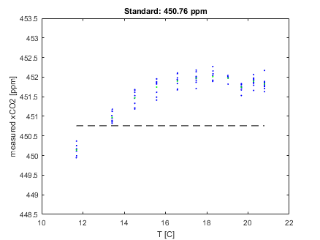
Figure 1. Sample calibration data for the 450.76 ppm standard.
Green dots are 10-sample averages over fixed T; black line is the known standard concentration (450.76 ppm).

2. Correcting for temperature

Two things to note are: (1) the T-vs-pCO2 relationship may be non-linear for a given pCO2 concentration (e.g., Fig. 1); and (2) the form of this relationship varies for different pCO2 concentrations (compare Fig. 1 and Fig. 2). In this example, the higher CO2 standard (450.76 ppm, Fig. 1) has a general positive trend to measured pCO2 as a function of T, whereas the lower CO2 standard (241.7 ppm – Fig. 2) has a general negative trend. The degree to which pCO2 measurements are affected by T is also a function of pCO2 – higher pCO2 concentrations are more affected by T than lower pCO2 concentrations.

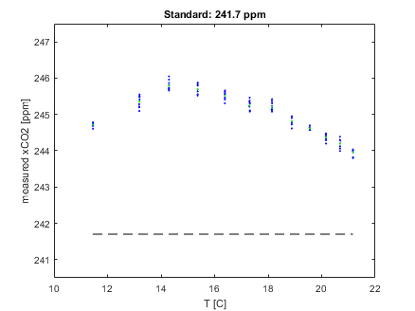
Figure 2. As in Fig.1, but for the 241.7 ppm standard.

The goal of the calibrations is to quantify the T-vs-pCO2 relationship over a broad, continuous range of pCO2 concentrations likely to be encountered in the field. One way to do this is to (1) generate individual T-curves for each CO2 standard in the lab; and (2) smoothly vary the shape of these T-curves from one standard to the next to fill the in-between concentrations. The result is then one smoothly-varying function that will provide a ‘custom’ T-curve at any given pCO2 concentration (not just the discrete standards).

Note the magnitude of the effect of temperature on pCO2 in the above example (Figs. 1 and 2) is only a few ppm. Varying T between 11-21 C has an effect of 1-2 ppm; a bit more (3-5 ppm) at concentrations > 1000 ppm, but this is rarely observed in the ocean.

3. Correcting for offsets independent of T

We are also seeing offsets between known and measured pCO2 which are independent from T, but are functions of pCO2. These can be very large, particularly at higher pCO2. In Fig. 2, the offset is ~4 ppm (i.e. the difference between the dots (measurements) and the black line (known standard)). Taking 'zero' and 'standard' measurements allows you to generate an ‘offset curve’ which is a function of pCO2. The more standards you have, the better you can resolve these offsets as a function of pCO2. Currently, most of our deployed CO2 systems have one ‘zero’ and one standard (typically ~400 ppm, room concentration, though we are beginning to use higher concentrations ~480 ppm). With just these two reference points, the offset curve is really a straight line. In the lab, we have one ‘zero’ and five standards. Data taken during lab calibrations show that the offset curve is non-linear (Fig. 3) and the slope decreases at higher pCO2¹. This is important because, if we used a line fit using a zero and one ~400 ppm standard, we would get a line extending all the way out to the highest pCO2 (Fig. 3).

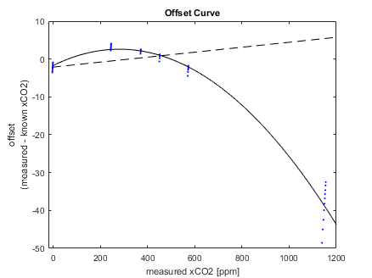
Figure 3. Offset curve using a zero + five standards (solid line)
vs. using a zero + one standard (dotted line).

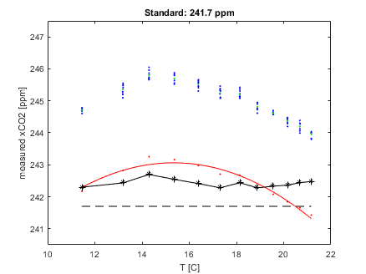
Figure. 4: As in Fig. 2, additionally showing (1) offset-corrected data (red dots); (2) T-calibration curve derived from the corrected data (red line); and (3) final data with both offset and T-curve applied (black asterisks). Final data are within 1 ppm across the range of temperatures.

4. Gernot’s method for applying T-calibrations:

These methods were taken off Excel spreadsheets created by Gernot for the ‘OA1’ and ‘OA2’ CO2 systems, filenames 08-27-13.xlsx, and 04-02-2013_Cal.xlsx, originally deployed at Cabo Pulmo and Terrace Point, respectively.

The method is: (1) fit a T-curve (2nd degree polynomial) to the zero standard; (2) apply this zero T-curve to all the other standards; and (3) generate a curve fit of the form: A + (B*temp) + (C*CO2) + (D*temp*CO2). The standard measurement becomes the span.

This approach works well (+/- 2 ppm) if the T-curve at zero is similar to the T-curve at all the other standards. But this is not always the case – every LiCor behaves differently and we’ve already seen that at higher pCO2, the shape of the T-curve can be completely opposite from that of lower pCO2. This method also does really poorly at higher pCO2 where there is often a large offset; although this is probably by design since Gernot doesn’t necessarily trust the pCO2 concentration in the 1188 ppm standard tank. It has been questioned whether the pCO2 concentration in the 1188 ppm standard tank is truly 1188 ppm. We measured the concentration of this tank in the lab at 1178 ppm using the Li-7000 on 8/31/2016. This is just outside the quoted error for the LI-7000, but much closer than the 40+ ppm offsets we’ve been seeing with the Wave Glider and OA Mooring (LI-820) systems. In order to move forward, I think we have to assume this tank is in fact 1188 ppm and that this offset is “real” and something we need to correct for.

5. Proposed new method:

- Correct for offsets independent of T, as in Section 3, by fitting a 2nd-degree polynomial curve to the measured offset;
- Generate individual T-curves for each CO2 standard in the lab;
- Fit the coefficients of the individual T-curves, to their own curves which are functions of pCO2. This will provide a ‘custom’ T-curve at any given pCO2 concentration (not just the discrete standards).

The final result of the calibration, then, is an equation of the form:

yFinal = yOff + (yOff - yTemp)

where:

yFinal is offset- and temperature-corrected pCO2;

yOff = y - A*y² + B*y + C
is offset-corrected pCO2;

y is measured pCO2;

yTemp = ([D*yOff² + E*yOff + F] * x²) + ([G*yOff² + H*yOff + I] * x) + (J*yOff² + K*yOff + L)
is temperature-corrected pCO2, and x is temperature measured by the LiCor in the air or equilibrator stream with the pump off.

6. In practice: Applying cal results to field data

The calibration coefficients only reflect the sensor’s measurement characteristics at one point in time and under ideal lab conditions. If the ‘offset curve’ is something that is intrinsic to the sensor and wouldn’t be predicted to change too much in the field, we can use the offset curve generated from lab cal’s as a reference, then use the in-situ, time-varying zero and ~400 ppm standard measurements to ‘nudge’ the curve. This way, our CO2-offset correction is not a 2-data point line, but a 6-data point curve, which is fine-tuned according to temporally-evolving field conditions. In practice, this is done by adding the equation for the in-situ 2-data point line (“field-nudged”) to the equation for the lab-cal 6-data point curve (“cal-derived”) (see Fig. 5, equation for “yOff”).

The next step is to apply the temperature correction. Here, we just use the equation derived during the lab cal (see Fig. 5, equation for “yTemp”) and assume that the effect of T on pCO2 is constant over time for a particular Licor. This is effectively equivalent to assuming whatever in-situ field correction that is necessary is taken care of by the offset-correction “nudge.”

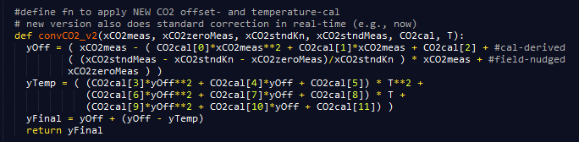
Figure 5. python code for converting raw xCO2 measurements.

7. Is all of this really any better than the method we’ve been using?

There are a couple ways to check. One is to compare results from the lab calibrations, where we actually have known standards to compare the corrected measurements to.

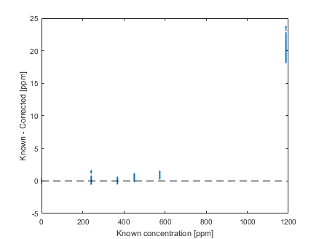

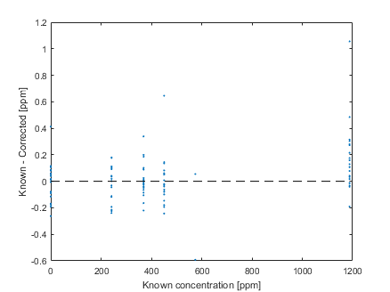
Figure 6. Difference between known pCO2 (as labelled on tanks in lab) and corrected pCO2 (measured in the lab with calibration coefficients applied). Top panel is Gernot’s method, bottom panel is proposed new method.

Both methods do very well at concentrations < 600 ppm, with differences of < 2 ppm; the key difference is at higher pCO2 (e.g., the 1188 ppm standard). Here, concentrations are off by > 20 ppm (or ~2%) using Gernot’s method, compared to within 1 ppm for the new method.

Another way, which has the added benefit of checking the in-situ field-corrections, is to compare sea water pCO2 with measured pH, using CO2SYS and an assumed alkalinity derived from salinity. Unfortunately, this also introduces more uncertainty – we can’t say for sure whether the pH measurements are perfect, nor whether the S-to-alk relationship holds for whatever water mass we’re measuring.

8. Precision of raw xCO2 measurements

As can be seen in Figs. 1 and 2, there is some variance in pCO2 over each 10-sample interval even at a nearly fixed T; however this is small (σ ~ 0.0 to 0.1 ppm regardless of T or pCO2) relative to the T-dependency and offset curves.

One final note: The LiCor factory-calibration sheets have shown that these sensors are better at measuring mid-range pCO2 concentrations compared to high and low extremes. This is what we’ve seen during our in-house lab calibrations as well (e.g., Fig. 3).

9. Conversion from xCO2 to pCO2

Finally, our corrected xCO2 measurements should be converted to pCO2. For air, we’re already done. For sea water, we need to saturate the air at 1 atm. Use the equation.

