For the old (differential) M1 system:

Past deployments:
//atlas/oasis_coredata/deployments/m1/yyyymm/pCO2/

Below corresponds to the New (absolute) M1 system.

Raw daily files:

Past deployments:
//atlas/oasis_coredata/deployments/m1-slave1/yyyymm/m1-slave1/pCO2/
There are only two deployments in here: 201309 and 201407. Apparently 201309 is when we first deployed the new system?

Current deployment:
//atlas/oasis_coredata/m1-slave1/pCO2/
Apparently these same files also get copied to the past deployment directory (above).

Calibrations:

CO2 cal’s are in //atlas/Diatom/Omegas_pH_new/calibration&config/pCO2/

Data collected during calibrations are in the OA1, OA2, OA3, … OA7 folders. It seems fine to me to keep them organized this way, but there may be a more appropriate parent directory for these folders, since M1 is not really part of Omegas. I propose ………..

In some cases the final coefficients have been derived in .xlsx files within those OAx folders. For others, there are just the raw *.cal files and I can’t tell where, or if, final cal’s were ever generated. I propose having a master spreadsheet where all the final cal’s are kept in one place for all the OAx systems. It would be organized like the Wave Glider calibration matrix (see below image).

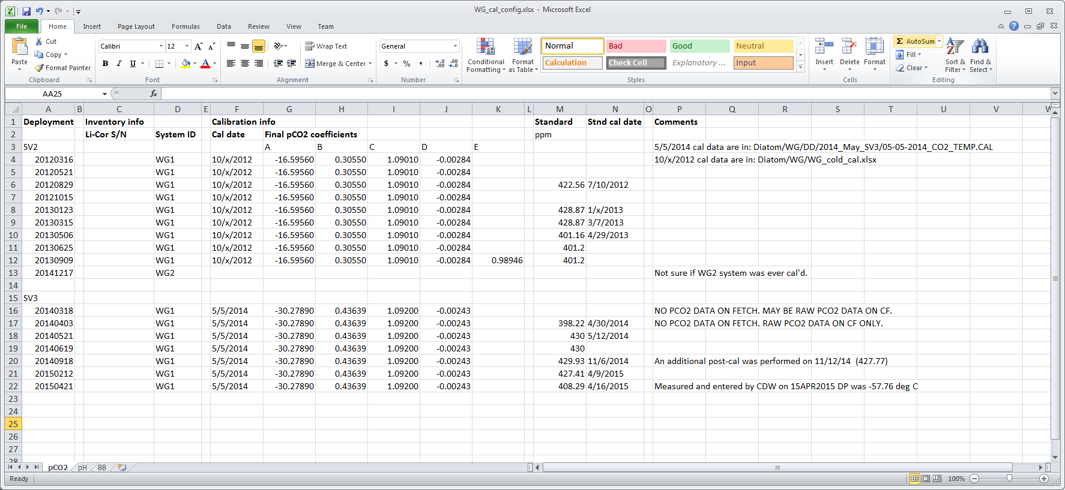

I wrote a Matlab script template (see 04-23-2015_OA6_cal.m) which reads-in raw ascii data taken during the calibration (in a *.cal file), allows some manual removal of bad data points, and generates a curve fit of the form A + B*temp + C*co2 + D*temp*co2. See Appendix 1 for details.

201309 used OA4, Licor S/N 940. Calibrated 9/10/2013. Coefficients were [-9.7396 0.274 1.0518 -0.0024053]. There is a .cal file. My Matlab routine gives.
I think 201407 was same system, different cal (check the cal dir).

pH cal’s are in //atlas/Diatom/Omegas_pH_new/calibration&config/pH/
MooringSensorCal_pH.xlsm

Data Processing:
1. OAx_yyyymm_cal.m to generate calibration coefficients from raw *.cal data file
2. loadM1_co2.m to load raw daily files into Matlab and apply calibrations

Appendix 1: Generation of CO2 calibration coefficients

Note, the columns of the *.cal files seem to vary, must manually enter in m-file.

//atlas/Diatom/Omegas_pH_new/calibration&config/pCO2/OA6/04-23-2015_OA6_cal.m

%define known std values (labelled on tanks in lab)
stdKn=[0 241.7 369.09 450.76 574.74 1187.94];

%import cal data
mydir=['//atlas.shore.mbari.org/Diatom/Omegas_pH_new/' ...
'calibration&config/pCO2/OA6/'];
myfile='04-23-2015_OA6';

fid=fopen([mydir myfile '.cal']);

% format is:
% (1) date, (2) time, (3) T, (4) p, (5) CO2, (6) ?, (7) std#,
% (8) set temp, (9) bath temp, (10) chamber temp

t=[]; temp=[]; press=[]; co2=[]; std=[];
while ~feof(fid)
fline=fgetl(fid);
f=strfind(fline,',');
s=str2num(fline(f(1)+1:end));
if length(s)==8 % or 10
t=[t; fline(1:f(1)-1)];
temp=[temp; s(1)];
press=[press; s(2)];
co2=[co2; s(3)];
std=[std; s(5)]; %or 7
end
end
fclose(fid);
clear fid n fline f s ans;

%time
time=datenum(t);
clear t;

%index according to std #
u=unique(std);
for n=1:length(u)
f{n}=find(std==u(n));
end
clear n;

%index 'good data' from zero
figure; hold on;
plot(temp(f{1}),co2(f{1}),'.');
ind=[12:length(f{1})];
plot(temp(f{1}(ind)),co2(f{1}(ind)),'g.');

%get linear fit to Zero m'ment as a fn of temp
p=polyfit(temp(f{1}(ind)),co2(f{1}(ind)),1);
plot(temp(f{1}(ind)),polyval(p,temp(f{1}(ind))),'k-');
co2Est=polyval(p,temp); %apply to ALL pCO2 conc's
co2Adj=co2-co2Est; %subtract 'estimated zero' from all conc's
clear ind p;

%index 'bad data' for other standards
% consider removing first (coldest) set of data points for each std
% consider plotting pressure as a QC check
for n=2:length(u)
figure;
plot(temp(f{n}),co2Adj(f{n}),'k.');
xlabel('T');
ylabel('CO2');
title(num2str(stdKn(n)));
end
ind=[f{6}(1:10); f{5}(1:10); f{4}(1:10); f{3}(1:10); f{2}(1:10)];
time(ind)=[];
temp(ind)=[];
co2Adj(ind)=[];
std(ind)=[];
clear press f n flag;

%re-index without bad data
for n=1:length(u)
f{n}=find(std==u(n));
end
clear co2 co2Est n; %clear old var's with old index

%define var's to model
ind=[f{2}; f{3}; f{4}; f{5}; f{6}]; %don't use zero data in fit
x=temp(ind);
y=co2Adj(ind);
z=NaN(size(time));
for n=1:length(f)
z(f{n})=stdKn(n);
end
z=z(ind);
clear f ind n;

%fit to curve using least squares and the 'fminsearch' fn which uses the
% 'Nelder-Mead simplex method'...
% See: http://www.walkingrandomly.com/?p=5196
fun = @(p) sum( (z - (p(1) + (p(2)*x) + (p(3)*y) + (p(4).*x.*y) )) .^2 );
pguess = [-10 1 1 -0.001]; %order of magnitude of a typical cal
p = fminsearch(fun,pguess);
co2Fin=p(1) + p(2)*x + p(3)*y +p(4).*x.*y;
rmse=sqrt( sum( ((co2Fin-z).^2)/length(z) ))
% Note, Matlab chokes if trying to use more complex version of fit:
% fun = @(p) sum( (z - ( ( p(1) + (p(2)*x) + (p(3)*y) + (p(4).*x.*y) ) + ...
% ( (p(5)*y.^2) + (p(6)*y) + p(7) ) ) * p(8) ) .^2 );
% pguess = [-10 1 1 -0.001 1 1 1 1];
clear fun pguess;

%print fit coefficients & RMSE to txt file
fid=fopen([mydir myfile '_calResults.txt'],'w+');
fprintf(fid,'%s\r\n\r\n',['JS ' datestr(now,'yyyy.mm.dd')]);
fprintf(fid,'%s\r\n\r\n','A + B*temp + C*co2 + D*temp*CO2');
fprintf(fid,'%s\r\n',['A = ' num2str(p(1))]);
fprintf(fid,'%s\r\n',['B = ' num2str(p(2))]);
fprintf(fid,'%s\r\n',['C = ' num2str(p(3))]);
fprintf(fid,'%s\r\n',['D = ' num2str(p(4))]);
fprintf(fid,'%s\r\n',' ');
fprintf(fid,'%s',['RMSE = ' round2(num2str(rmse),0.0001)]);
fclose(fid);
clear fid;

