BIN status check via acoustic link
Tom O'Reilly
11/13/2015

Started attempted contact at 9:25 PST, WG approximately 500 meters north of BIN. Took a few hours to find location giving best acoustic communication between WG and BIN.

Best acoustic communications while circling waypoint 3 (BIN at waypoint 1) with 100 meter radius - see figure 1. In this region, we get valid response to 'atr9' command approximately 75% or better.
Both modems at maximum xmit power, both at 300 bps

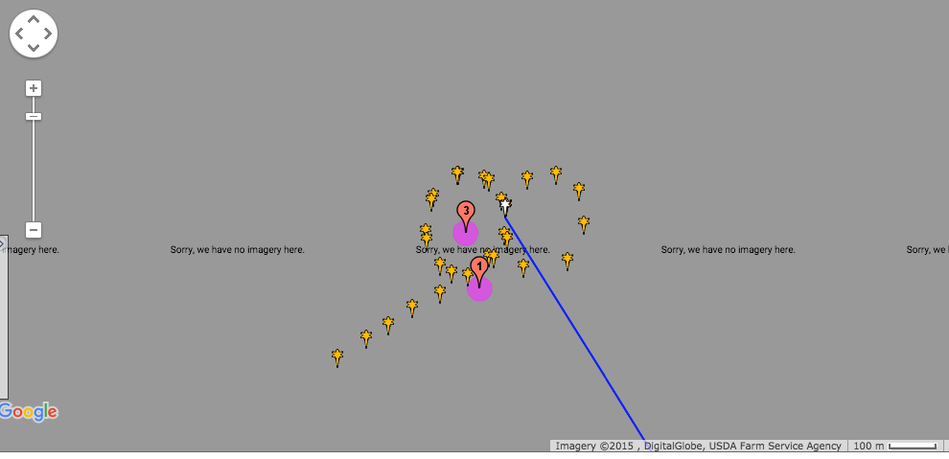
Figure 1: BIN (waypoint 1) and WG watch circle center (waypoint 3)

Local Sregisters
S00=810 S01=000 S02=000 S03=130 S04=003 S05=000 S06=008
S07=019 S08=060 S09=000 S10=036 S11=000 S12=000 S13=003
S14=000 S15=000 S16=001 S17=001 S18=010 S19=000 S20=000

Got BIN power bus voltage
user:34>at$v9
Tx time:17:30:11.9000
Rx Time:17:30:16.3534
Remote Battery Voltages
DSP Bat = 03.0V
Xmit Bat = 14.8V

Got remote S-registers
S00=042 S01=000 S02=000 S03=004 S04=006 S05=000 S06=008
S07=015 S08=100 S09=000 S10=036 S11=000 S12=000 S13=000
S14=000 S15=001 S16=001 S17=001 S18=009 S19=000 S20=000

Connected to BIN via acoustic (atd9 command). Note noisy/corrupted response to linux commands.

Got BIN environment data from MSP430 sample:
SIA?%s??o? $?ams>֨?'??450:t?parenlID1598, rd???d?y<\=1
devid=15c?? ????474??1??Q??K?t;o=4899S zN??Kx305
nByt?_??G
$PEDATA, P790.05, T10.05,PH?&5?, GFL-4:.99, GFH5.38, C260M?, TC0.00, *3716
\P?h?ss: 790.0{ ?illibar
tmprt: 10.05 deg C
kumid: 3.52 rel %
GF-low: -48.99 microAmps
GF-high: 5.38 microAmps

'listPorts' response indicates no sampling errors, expected number of samples since last node reboot on 10/12/2015 (just prior to deployment).

listPorts loc -stats
Node 1598Vs 14 ports
Port Name
I?/-?l Service Status: S E R
--------- ------ ------- ------ --- --- ---
/dev/ttySX0-?g??3?G1???۠ - ? ? ? -
/dev/ttySX1 1533 SBE-19+ SAMPLING 13782m? M0 0
/dev/ttySX2 1535 TriplKt slv to 1827 OK 274959 0 0
/dev/ttySX? 1474 "X?^9?? Aquad??? SAMPLING 275640 0 0
/dev/ttySX4 1524 Optode slv toQ?ԯ}y OK 274959 0 0
/dev/ttySX5 188=? 300kHz AE?~???PLING 275632 0 0
/dev/ttySX6 1828 600kHz ADCP SAMPLING 275626 0 0
/drK/tX?X7 1827 1200kHz ADCP SAMPLING 274957 0 0 Ho /dev/ttySSw :)^? - ! - - - ?
/dW??tySX9 - - - " ???

/dev/ttySX10 - $ - - - v?
/dev/ttySX11 - - - - ??
/dev/ttySX15 1599 MSP430 OK 4682T? 0 0
4/dev/ttySA2 - - - -

Verified latest BIN boot date:
nodeInfo loc
SIAM version $Name: $
node2/134.89.36.2
Unknown switch IP addr
device ID: 1598
node started at 10/12/2015 21:28:26 GMT

Checked RTC and sys clock times: note that sys clock has drifted approximately 330 seconds in 31 days, while RTC is within 10 seconds of network time (can't determine accurately due to acoustic delays on link):

Issued at 11:32:27
/root/ricohRTC
System time: Fri Nov 13 19:37:57 2015

RTC Time: 13/11/2015 07:32:35 PM

